*Energy Efficiency Sharing*

*By: Julien Homble*

*Abstract*— The motivation behind this research is to increase energy awareness in everyday people. Energy consumption data is not readily available for individuals to see. In addition, if people are not in charge of managing or paying for the utilities, many will not take simple steps to save energy. It is the goal of this research to develop a mobile application that will promote energy savings among people that would otherwise not think to. These savings would be in public buildings or facilities that the users of them do not directly pay the utilities. The result of this research has been an application named EEShares (Energy Efficiency Sharing) which allows facility managers to connect and promote energy savings to the people using the buildings. The application will be implemented for full testing in the Spring of 2017.

# Introduction

The reasons to save on energy are obvious. It is better for the environment, saves money, makes devices more efficient, etc. However, engaging people to be more energy efficient can be difficult. Putting up flyers, statistics, and events may have an initial increase in energy savings, but are not effective for long term improvement. To sustain this improvement, a change in how people see energy must be reached. If given a continuous opportunity, reason, and incentive to promote better energy consumption habits, increased energy efficiency can be reached.

# problem

The issue with having people save energy in public buildings is not whether they are willing or capable, but is to make them aware. Many people do not consider these costs, especially if they do not need to pay for them. However, if asked whether they would be in favor to save energy and help the environment, and overwhelming majority would say yes. For example, an office, a dorm, or a lecture hall, are all buildings that people use regularly without having to consider the energy use. However, to the person who must pay these bills, saving energy is a great way to help the environment and save money. The problem in this is a disconnect from the people using the facility with the owners and the responsibility to save energy. People do not want to take responsibility of the energy expenditure if they do not have to, and thus never think about it.

# Solution

Our solution was to develop an easy to use, intuitive mobile application. The application will connect the people who use these buildings to the owners or people in charge of paying the energy bills. The application will be a social platform where facility managers and users of the buildings can discuss energy saving goals. Users will be ranked based on their involvement in energy savings, and incentives will be added to each energy saving campaign. Each feature in the mobile application is aimed towards involving the users more into saving energy and using the application.

During the Spring of 2017, we will be conducting an experiment testing our theory as to whether we can engage public building users to be more energy conscious. By creating and releasing this application, I will be able to reach out to the students at the University of Maryland and engage them in our experiment. With the students involved, I will be able to test whether my team’s effort in increasing energy savings can be reached.

# Design

The application will be developed for both IOS and Android users. Facility managers will contact us if they decide to start an energy savings campaign. Once in contact, we must discuss how to retrieve the energy statistics of the buildings they want to link to our application accurately and efficiently. For the purposes of this experiment, University of Maryland buildings have been chosen.

This application will serve to connect users of a building to the facility management, display energy statistics, and provide an incentive to save energy. Using these three means, the users of the application will be more informed and willing to be more proactive in their energy savings. In order accomplish this, the application is designed to create campaigns on buildings. Campaigns can be thought of as energy saving goals where the owner of the building invites the people who use it to join a group. Once in the group, users can see the current energy statistics, the goal of the campaign, tasks to save energy, other members, and incentives to save. Each of these aspects will be discussed further below.

# Connecting Users to Facility Management

This is the first goal of the application. By connecting users to the owners of the building, they are now closer to taking responsibility for the energy use of the buildings. The facility management knows the current billings for the buildings and can be realistic when setting energy saving goals. Each building can be vastly different and the impact the users of the building can have on saving energy varies. Some buildings must be running at full power all day and so the users of the building may only have a negligible effect on saving energy. Whereas others, the members of the building collectively can make a clear reduction in costs. Once a campaign is set, the owner will invite the members of the building to the campaign. Based on the facility, the owner must set an appropriate goal that can be reached and tasks the members of the campaign can complete. Both the goal and tasks will be unique to each campaign. For example, an athletic facility may set a task to turn off all treadmills and TVs, whereas a biology lab may be to turn off fume hoods. By connecting the members of the building with the owners, they will have meaningful tasks they can complete that can have an impact on the energy costs of the building.

# Displaying energy statistics

Displaying the energy statistics of the buildings is vital for the application. It is not enough for us just to tell the members to save energy, there must be a means for the members to see change. By providing the current energy statistics, there is instant feedback to the user. Without it, the application would be no different than just a poster board in the front of the building with energy saving tips. It is key for our users to come back to the application to be reminded of energy savings. We believe that just by using the application, users will be more energy conscious which is the first step to becoming more energy efficient. The comparison of the current energy statistic to the starting and goal will serve to motivate the user to either do better, or continue their savings.

# Incentives to save energy

The largest motivator to come back to the application and save energy will be our incentive approach. Without means of receiving any incentive, the application will only be used for so long. To motivate users to complete the tasks and save energy, we will offer prizes and incentives to the user. For the prizes to be given, the goal of the campaign must be reached. Therefore, the first step in receiving a prize is first as a group, the campaign goal must be met. Once the goal is reached, prizes will be open. To reward users who more actively involved themselves in the application and savings goal, participation in the application while the campaign is active earns points. Users can then use their points to raffle in prizes at the end of the campaign. Ideally, the energy savings from the facility will pay for the incentives themselves, thusly making the application self-sufficient.

# Plan to complete

To build the application described, several services and software were required. Over the course of the Fall of 2016, several different iterations and designs changed. The final design of the application used an Ionic UI design utilizing Angular JS and the Cordova plugin. Google’s service Firebase, was used for the backend of our application to send information to the handheld devices. Finally, a Node JS server was implemented in the University to communicate with the University of Maryland’s Data Warehouse which stores UMD’s energy meter values.

Using Ionic, Angular, and Cordova, I could write both the Android and IOS applications as websites using HTML and Java Script. Once the website was finished I could then convert the web code to the respective mobile applications. Utilizing these tools, I could develop the front end of both applications simultaneously and both would visually and functionally be identical.

The information displayed on the application will be loaded in from a Firebase Backend as a Service. This service will handle all authentication, security, messaging, and real time data. The service allows the developers to build and deploy professional applications with security, scalability, and easy to use API. Everything the users will see on the application will be loaded from Firebase, and any changes push to the Firebase database updates the applications immediately.

The last portion of the application needed is the facility energy information. Without the meter readings for water, electricity, heating, steam, etc. on the buildings, we will not be able to set the goals of the campaigns and give the users the current energy statistics. For this, we will request access to the University’s Data Warehouse which holds all facility energy information. Once access is granted, we must establish a server linked to a University of Maryland IP address (access to the Data Warehouse is only granted with a UMD IP address). The server will query the Data Warehouse database and store the information into our Firebase service which will update the Android and IOS applications.

# What has been completed

At the completion of the Fall 2016 Semester, the UI design and Firebase service are set up and running. Both the Android and IOS applications have fully functioning UI designs that send and receive all information to the Firebase service. In addition, I have full access to the Data Warehouse and the University server is running. From the server, I can query the Data Warehouse Database and extract any information out of it. With this, our application has the entire framework required to be successful.

# Difficulties

Many difficulties occurred during the project with complete redesigns of the framework of the application. Originally, the application was built natively through Android Studios and Java, and Xcode and Swift. Also, the entire backend system was built through a PHP server hosted by an Amazon Web Service. However, the main obstacle faced which was unexpected was access and querying the Data Warehouse. Reaching out and working with facility management was a very lengthy and time consuming effort of contacting different managers, IT workers, and department heads. What seemed as a though a simple online application was over a month’s work of tracking down who could give us permission, and who knew where the information we needed was stored. In the end my team and I developed a consistent communication network with facility managers who have been helping us read the information we needed.

# Next Steps

The next steps of the project will be the deployment of the application. This semester has been the development of the application and planning of our research efforts for the following semester. In addition to the mobile application, I have applied for a $40,000 Sustainability grant from the University to fund all services fees and incentives for the campaigns. The results of the grant will be announced early next year and will be a great means for motivating the users. Once all team members approve the application, I will submit it to the Android and IOS App Stores for download.

# Conclusion

This project has seen great promise. Several outside sources have taken keen interest in our application and research efforts. In addition, the development of the mobile applications and backend have been a tremendous learning experience for me as well. I have learned the full stack development from planning, design, implementation, and finally deployment. I have played a critical part in the management of not only the application but the entire project. I am confident in the application and the results it will yield next semester.

References:

Shen, Meng, Qingbin Cui, and Liping Fu. "Personality Traits and Energy Conservation." Elsevier (2015): n. page. Web.

Shen, Meng, Robert Young, and Qingbin Cui. "The Normative Feedback Approach for Energy Conservation Behavior in the Military Community."

Department of Civil and Environmental Engineering, University of Maryland/ College of Management and Economics, Tianjin University, 2015. Web.

Supervisor:

Cui, Qingbin

Associate Professor

1157 Glenn. L. Martin Hall, College Park, MD 20742

Email: cui@umd.edu

Phone: 301-405-8104

Sample Application Images:

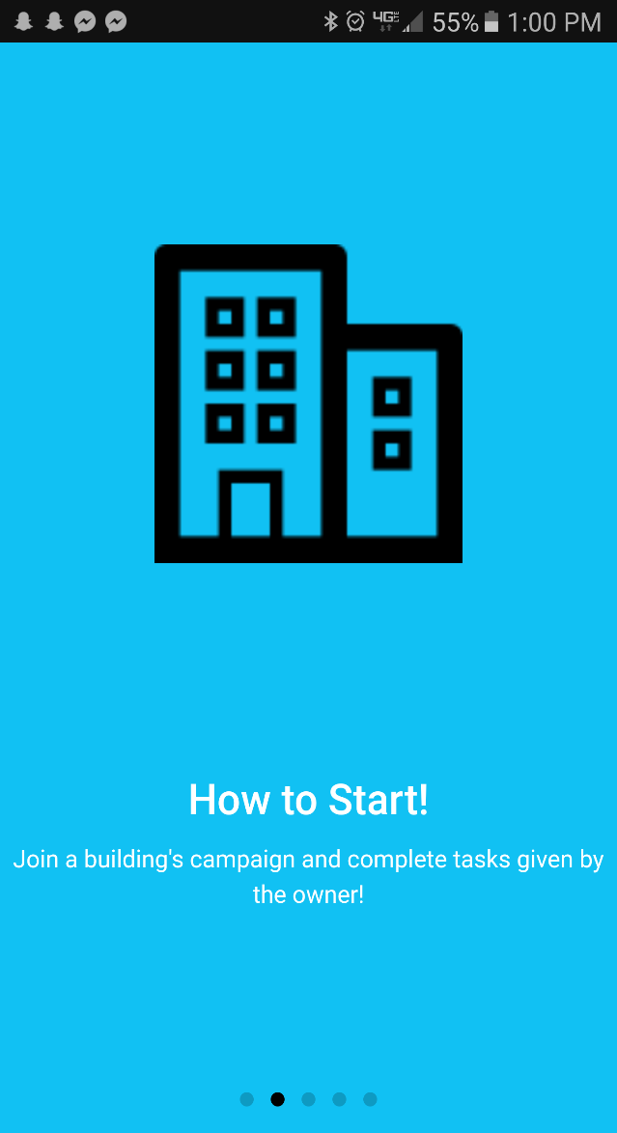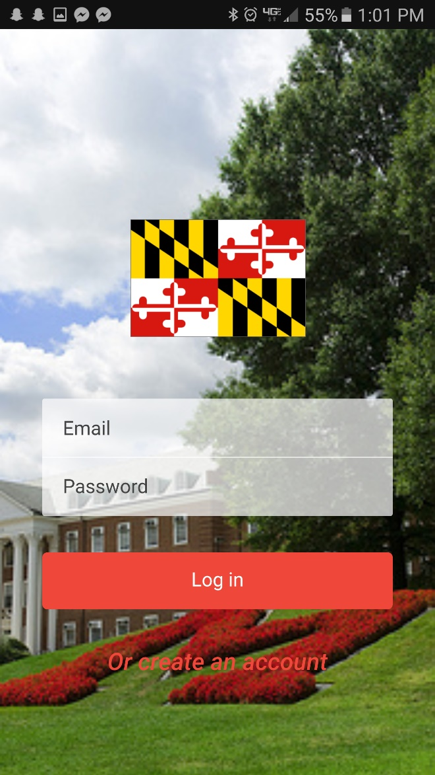

Log in Screen

One of Five Slider Pages to introduce application

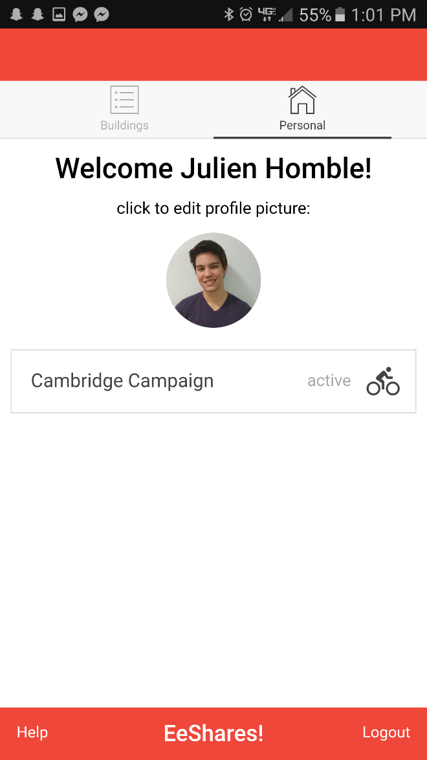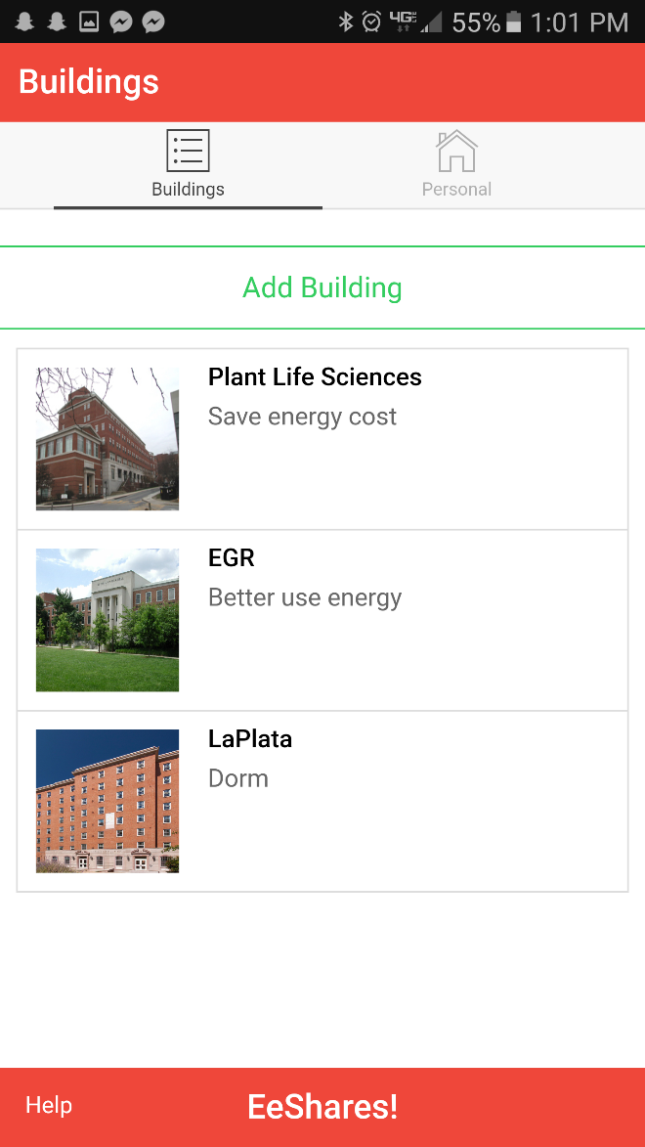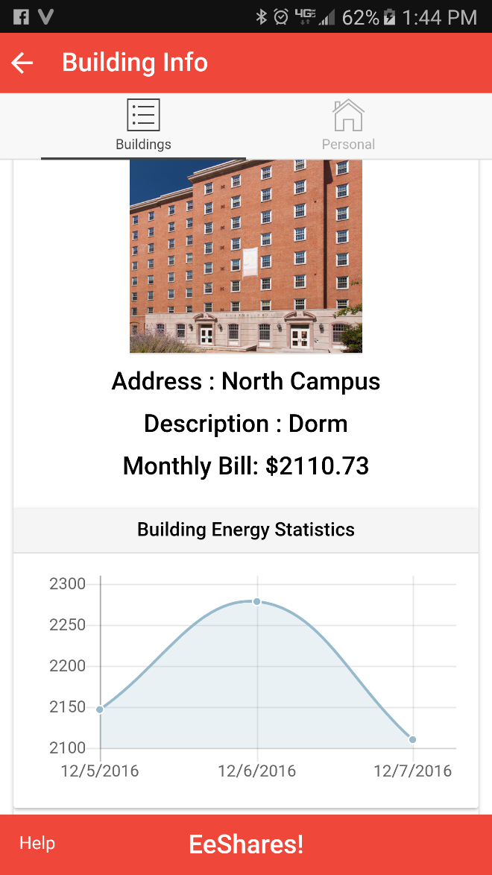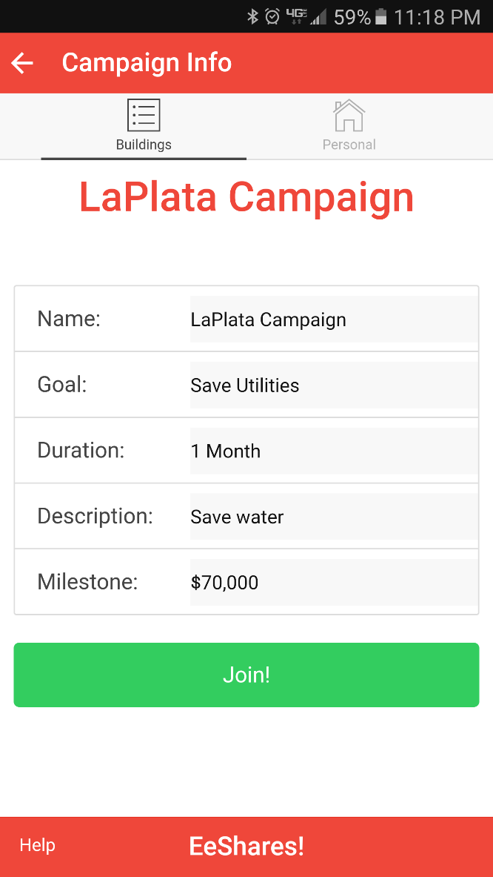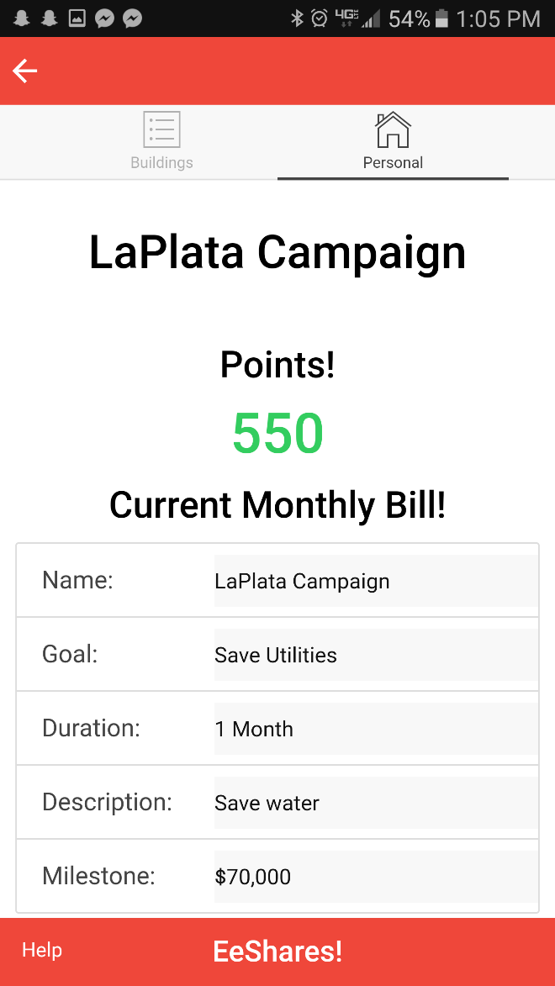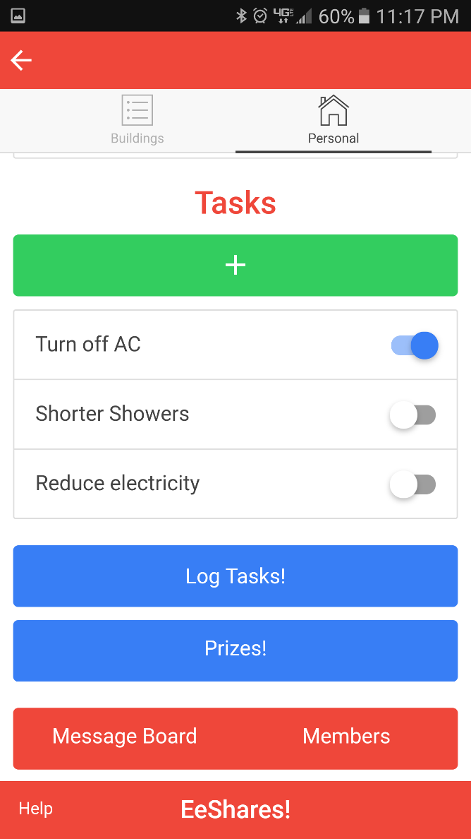

Building Page. See currently added buildings in application and join their campaigns

Home Page. Edit profile and view currently enrolled campaigns

Building Campaign Page. See a buildings active campaign. Join the campaign if you know the correct password

Building Info Page. See Current Statistics on a building and join a campaign if set

Campaign Info Page. See personal points, descriptions, and statistics of the campaign

Campaign Info Page Cont. See the current tasks users can complete, log your activity, see the message board and other members

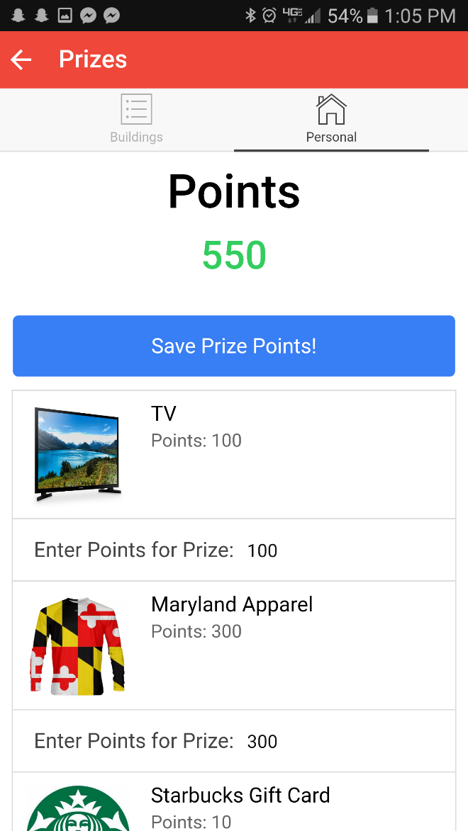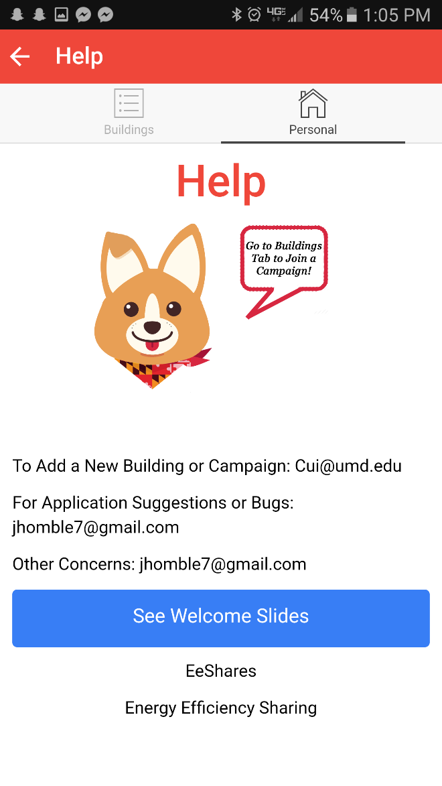

Help Page. See contact information or see intro slides again

Prize Page. See the incentives currently offered in the campaign. Enter points to win